**PROJECT REPORT**

(SUMMER TRAINING)

## E-HEALTH CARE SOLUTIONS

Submitted by

**Mr. NAMAN GARG**

**Roll No. 101253010**

Under the Guidance of

# Mr. Faiz Muhammad Ali Khan

**HPES, Noida**

# Department of Computer Science and Engineering

**THAPAR UNIVERSITY, PATIALA**

**August 2014**

# DECLARATION

I hereby declare that the project work entitled **“E-HEALTH CARE SOLUTIONS”** is an authentic record of my own work carried out at **HP EDUCATION SERVICES, Noida** as requirements of 6 weeks summer training for the award of degree of B.E. (Computer Science & Engineering), Thapar University, Patiala, under the guidance of **Mr. Faiz Muhammad Ali Khan**, during 16th June to 31th July, 2014).

I further declare that no part of this report is copied from Internet or any other source.

**NAMAN GARG**

Roll No.101253010

Date: ___________________

**ACKNOWLWDGEMENT**

### I take this opportunity to express my sincere thanks and deep gratitude to all those people who extended their wholehearted co-operation and have helped me in completing this project successfully.

### Special thanks to **Mr. Faiz Muhammad Ali Khan** (Project Manager and Trainer) for all the help and guidance extended to me by him in every stage during my training. His inspiring suggestions and timely guidance enabled me to perceive the various aspects of the project in a new light.

### I am highly indebted and graceful to the whole team of **HP EDUCATION SERVICES** for Their strict supervision, constant encouragement, inspiration and guidance, which ensure the worthiness of my work. Working under them was an enrich experience. I express my sincere thanks to my senior of software development department for their encouragement and valuable suggestion

### In all I found a congenial work environment in **HP EDUCATION SERVICES** and this completion of the project will mark a new beginning for me in the coming days.

### NAMAN GARG

### BE 3rd Year CSE

### Roll no: 101253010

**ABSTRACT**

The main aim of the project is to develop an E-HealthCare Solutions for the online interaction between doctors and patients saving the time money and distance. The module enhances Interaction/communication facilities between the patients, doctors and Site Administrator. The site contains separate modules for patients, doctors and admin, each can login their account using username and password.

E-Health Care Solutions allows patients to directly contact doctor without any need to go to the doctor’s place .Patients can further edit their profile information, view the list of all the doctors available in the database.

System also provides an editable and secure doctors account where they can view all the messages by their patients and respond any time they want.

An Admin account is maintained to coordinate the overall working of the system where he can delete account of patients and doctor at will and see all the profiles of doctor and patients as well .

**TABLE OF CONTENTS**

S.No CONTENTS PAGE No

**1. INTRODUCTION 7**

**2. BACKGROUND 9**

2.1 EXISTING SYSTEM

2.2 PROPOSED SYSTEM

* 1. SYSTEM SPECIFICATIONS

**3. DESIGN 12**

3.1 Entity Relationship Diagram

3.2 Flowchart and Level 0 DFD

3.3 Level 1 DFD

3.4 Use Case Diagram

**4**.  **PROJECT MODULES 17**

* + 2. **5. LIMITATIONS 24**
    4. **6. CONCLUSION 23**

**7. FUTURE ENHANCEMENTS 24**

**8. BIBILIOGRAPHY 24**

HPES, NOIDA

HP Education Services provide IT Professionals, enterprise businesses and end-users with the highest quality, most comprehensive, technical and business education services and expertise using advanced technologies.

**HP** believes that we never stop learning, and therefore we emphasize on making developers and managers fully aware of new technologies. Sophisticated, new technologies can be optimized for business benefits only if supplemented by sufficient knowledge and training for implementing it.

Keeping in mind that your employee’s time is a valuable resource, we have created a full suite of training programs

**HP** provide a fully integrated learning environment. This includes self-paced, web-based, distance learning and online seminars via our innovative online offering the IT Resource Center,

**HP Education Services** provides the industry's finest integrated learning curricula which includes e – learning, online forums, resource center and virtual classrooms for mastering new technologies. **HP Education** provides instructor led and online training with customized content to suit specific needs, ensuring the success of both, the individual IT professional and the enterprise.

**1) INTRODUCTION**

**E Health Care Solutions** is a web based application created for saving the time money labor and managing cost in medical industry. The application enables patient to access health consultancy services by viewing all the doctor’s profile available sorted by their respective area of specialization and later message the symptoms they have, doctor can view all the messages in his inbox and reply to them appropriately. It saves a lot of paperwork, time and money of patients and doctors.

This system is made of

* **Login Module**
* **Registration Module**
* **Search/Edit/Delete Module**
* **Message Module**
* **Feedback Module**
* **Notice Module**
* **Loan Module**

**SCOPE:**

* E-Health Care solutions covers the patient doctor profiles where they can create and manage their accounts.
* Message module for patient doctor and admin allowing the whole diagnosis process occur online.
* It allows new doctor to upload their photos and resume for the patients to view providing a more favorable health market.
* System also provides loan module which considers the income and family background of patient.
* System also includes the feedback notice and last login status.
* Dynamic appointment module is out of the scope as it involves mapping and exclusiveness.

**UTILITY:**

E-Health Care solutions can easily be utilized in any health care center, hospital, and clinic or in any remote health facility. Once installed the system can be accessed by anyone on the internet. Its helps in

* Saving money time and labor making whole system online.
* Reduces paperwork by making all data available online reducing inaccuracy.
* All the profiles are editable and manageable.
* Records of patients and doctors can easily be sorted by name or department.

1. **BACKGROUND**

1. **EXISTING SYSTEM:**

The existing Health System falls short of making health consultancy services available in all parts of India. A lot of time and money is wasted to get adequate health facilities. The current system is slow laborious and error prone to computerize the same for quicker results and efficiency.

DRAWBACKS IN EXISTING SYSTEM**:**

* It is not possible to get all the doctor’s at one place and time.
* It used to take much time and money to get guidance from doctor
* Lot of paper work makes the system inaccurate.
* Danger of losing patient and doctor details.
* Prescription gets lost after a certain time.
* Searching the patient records is a tedious task.

2. **PROPOSED SYSTEM**:

The present target of the project is to mimic the actual existing system as it is in the proposed project**. E HealthCare Solutions** in every medical department will reduce the manual work. Now patients can be registered online, all their details and health problems will be known prior to his visit which could save time. The system has 3 main profiles:

* Admin who can:
* Manage doctor and patients.
* Approve doctor and patients.
* Search for the patients/doctors
* Upload a notice.
* Patient who can:
* Submit the Symptoms
* Apply for a loan
* Manage his profile
* View all doctors
* Give Feedback
* Doctor who can:
* Reply to patients queries.
* Give Feedback.

ADVANTAGES OF PROPOSED SYSTEM**:**

* Very fast accurate and reliable.
* No need of any extra manual effort.
* User friendly and dynamic system helps patients and doctors get the job done easily.
* Just need a little knowledge to operate the system.
* Doesn’t require any extra hardware device.

**MINIMUM HARDWARE CONFIGURAITON**

* **Microsoft Windows XP Professional SP3/Vista SP1/Windows 7 Professional:**
  + **Processor:**800MHz Intel Pentium III or equivalent
  + **Memory:**512 MB
  + **Disk space:**750 MB of free disk space

**SOFTWARE REQUIREMENTS**:

* **Operating System :** Windows XP, Windows 7/8
* **Programming language:** Java
* **Web-Technology:** Servlet, JSP
* **Back-End:** Oracle JDK 1.8,JRE 8.0
* **Web Server:** Apache Tomcat 7.0
* **Database:** My Sql 5.6
* **Web Authoring Tool:** HTML

**3) DESIGN**

Design is the first step in the development phase for any techniques and principles for the purpose of defining a device, a process or system in sufficient detail to permit its physical realization.

Layout of the whole project has been explained with the help of the Use Case Diagram and the Activity Diagram below.

Use case diagram is used to show the dynamic behavior of a system. Admin patient and doctor are the 3 external actors used and their relationship is shown with the internal functionalities i.e. loan module, login module, message module. Each module shows the sub modules it requires to run using include.

Entity Relationship Diagram is used to show all the tables present inside database health, their attributes and relationship among each other.

Data Flow Diagram is used to show the flow of data along all the processes in the database.

Flowchart has been used to explain the flow of program in case a user logs into the system and the actions he can perform.

**ENTITY RELATIONSHIP DIAGRAM:**

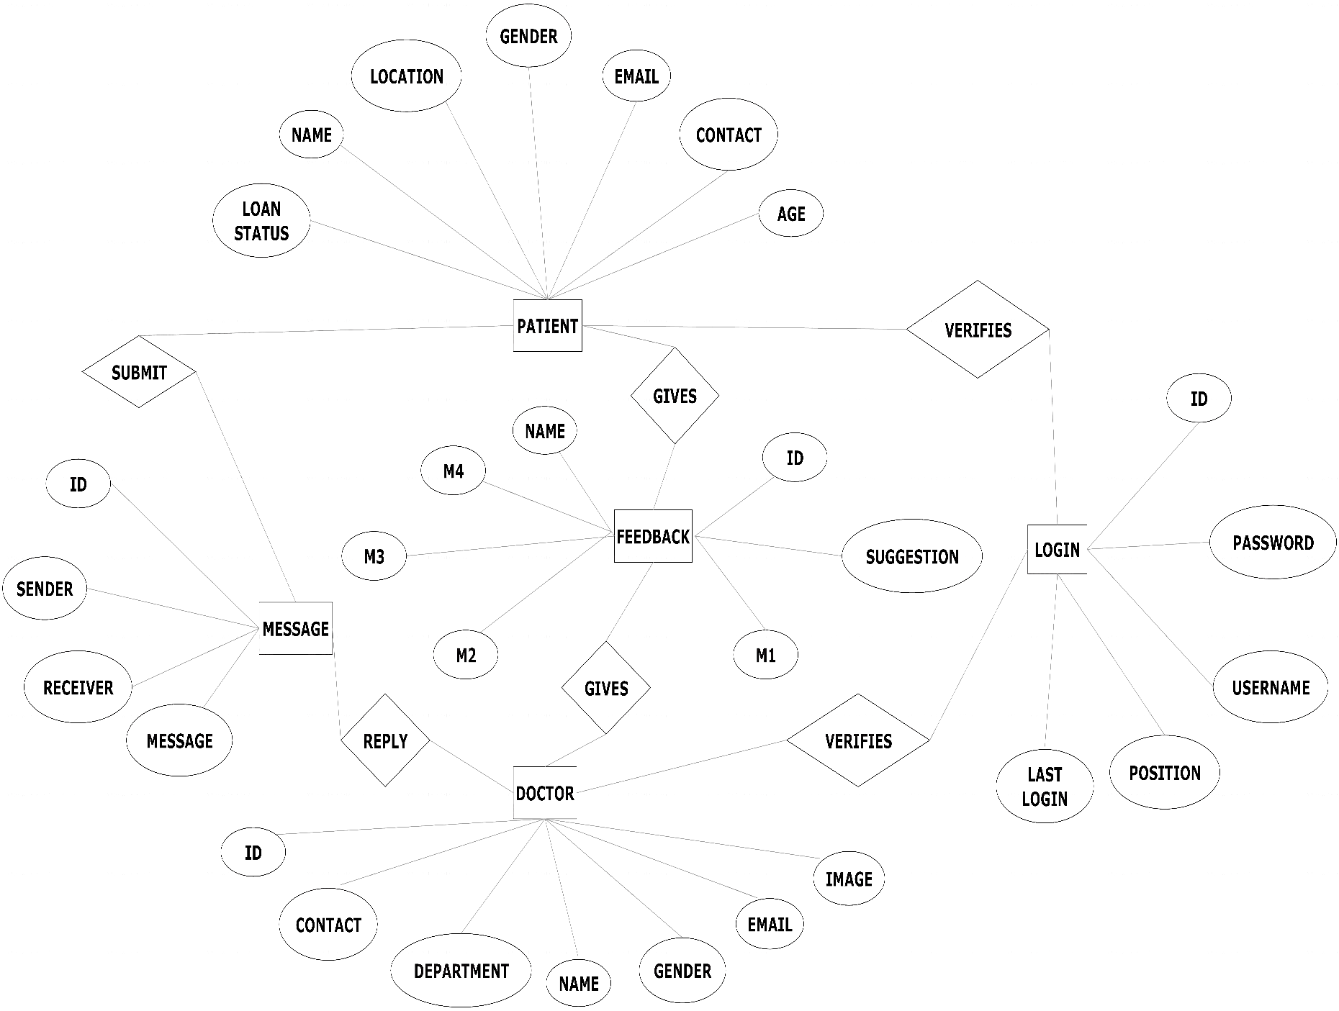

**FLOW CHART:**

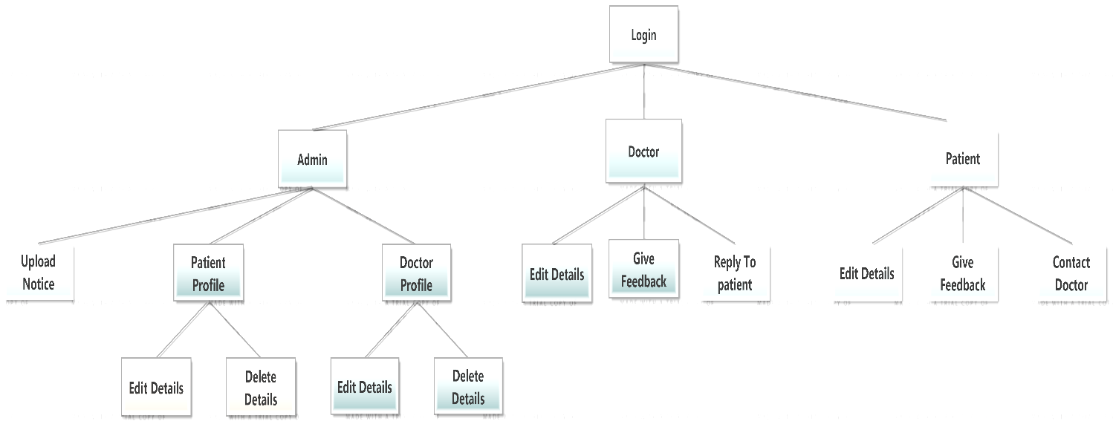

**LEVEL 0 DFD DIAGRAM:**

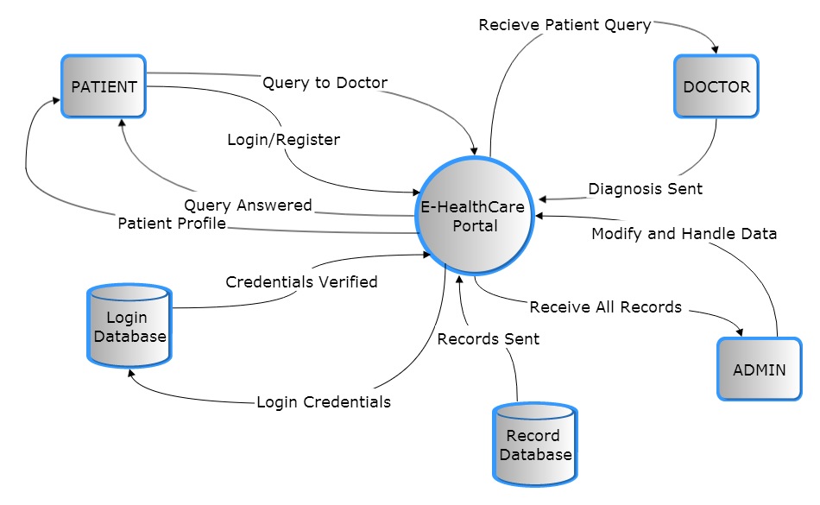

**LEVEL 1 DATA FLOW DIAGRAM:**

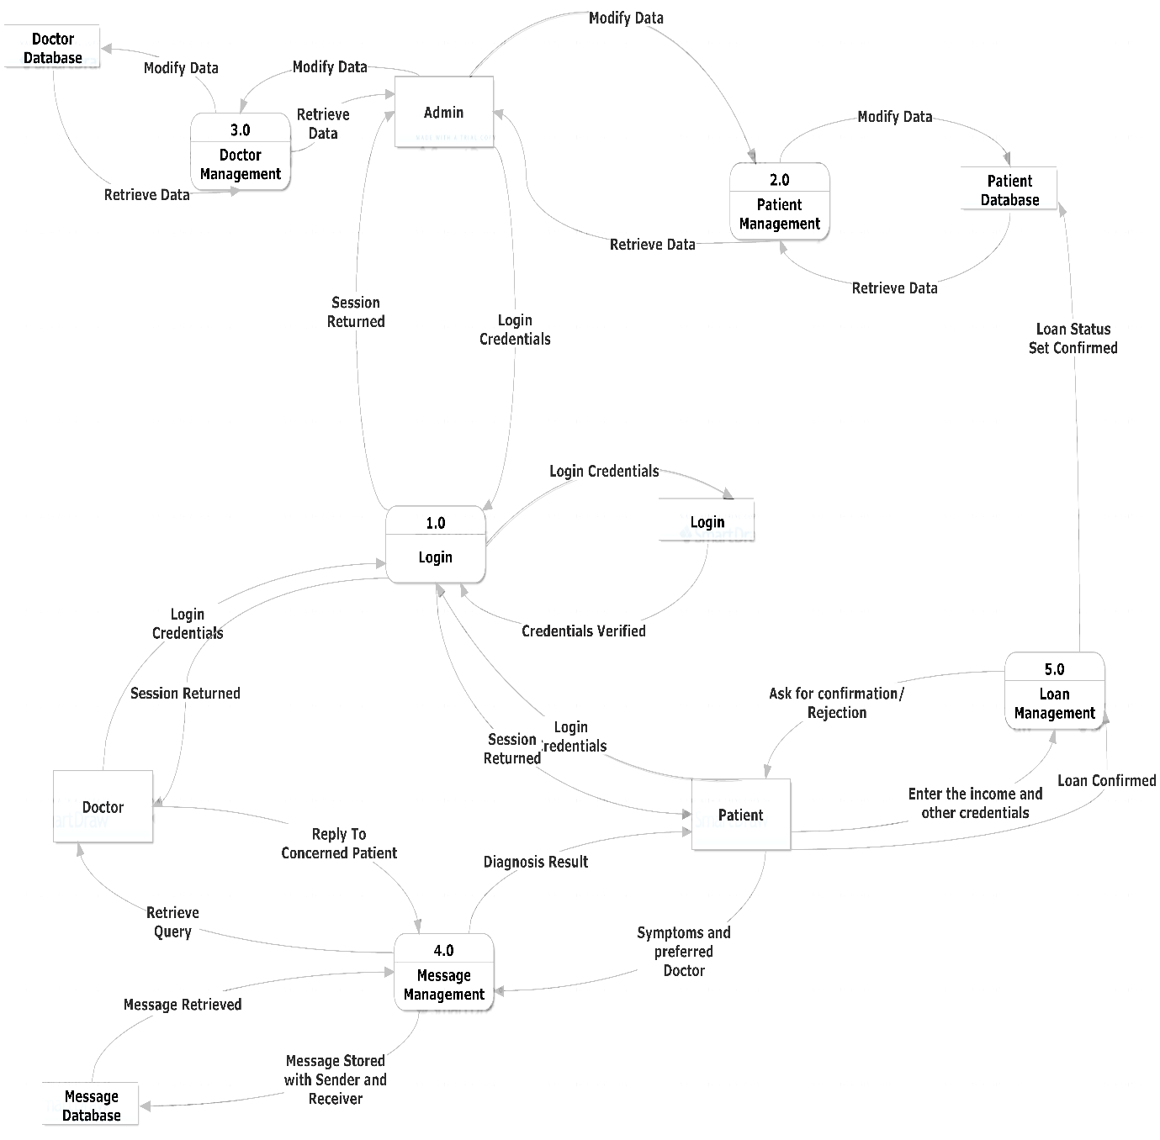

**Use Case Diagram:**

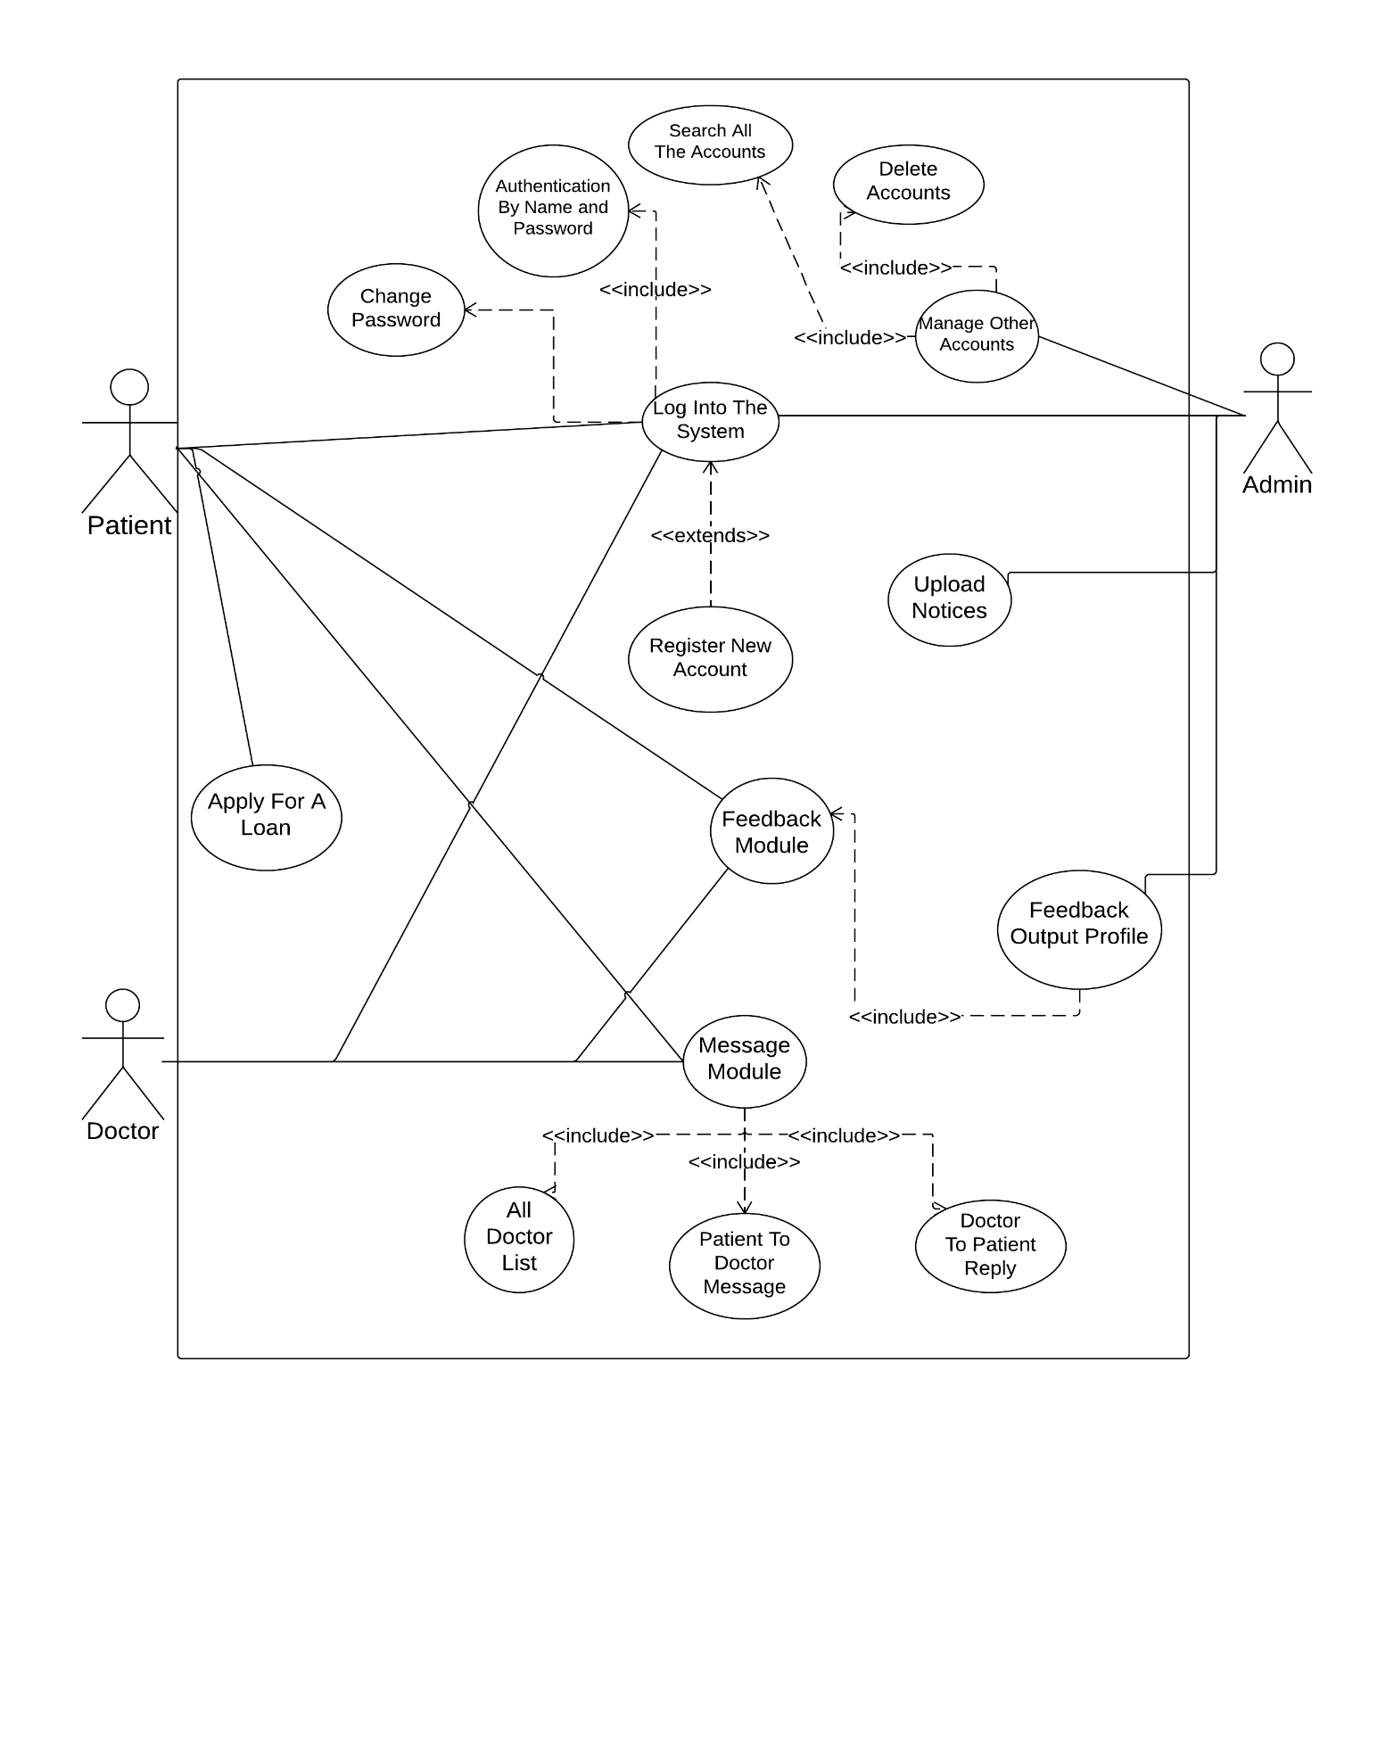

1. **PROJECT MODULES**

The list of modules incorporated with Human Resource Module is:

Name of the Module-1: **Patient/Doctor General Details Module**

**Description:**

This module generates patient’s general information along with contact, e-mail, location, gender and age information for the Doctor and Admin to view. It also generates the doctor’s general information along with his area of specialization, contact, e-mail id, image, resume and gender for the Patient and Admin to view

Based on the specialization provided by the doctor he/she will be assigned shown into their departments.

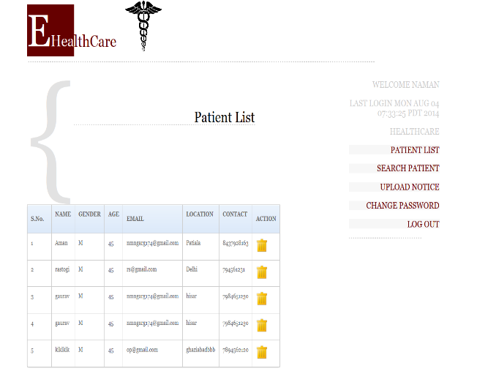 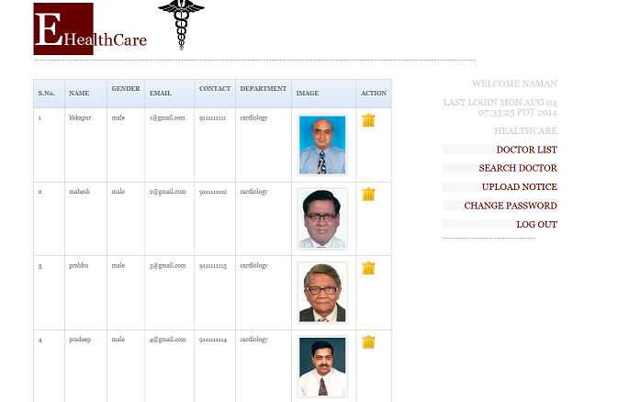

Name of the Module-2: **Login Module**

**Description:**

This module has control over the login activity of the patient, user or admin. A person enters his username and password, system verifies them from database and module is presented to them as per their role.

Sub Modules:

* Sign up as patient or doctor
* Last login details

Sign Up Module:

It allows new patients and doctors to register into the system. Username for each user is unique. Doctors need to upload their photo before signing up.

Last Login Details:

It stores the current date and time of login of a user in database and shows it the next time he logs in, making system more secure.

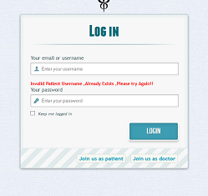 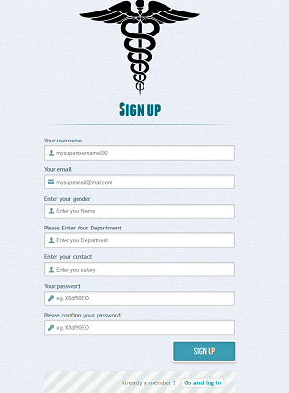 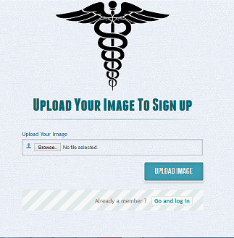

Name of the Module-3: **Search Edit and Delete Module**

**Description:**

These modules deals with the management of profile. A client can edit his profile any time but he can’t edit his name which is unique. A search module has been provided to Admin to find any profile he wants and he can delete any profile he finds fake.

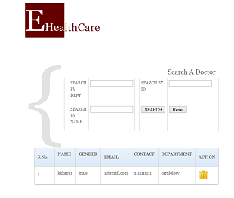 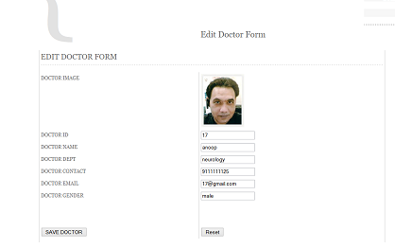

Name of the Module-4: **Upload Notice Module**

**Description:**

It allows the admin to post a notice to all the users registered in the system. It shows the type content and date of the notice.

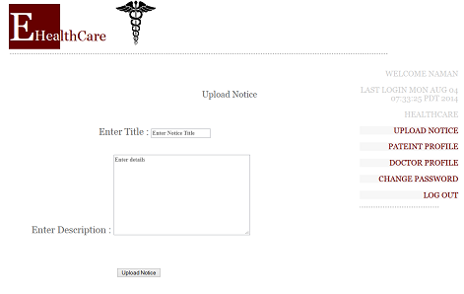 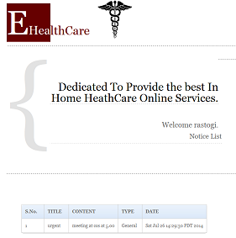

Name of the Module-5: **Messaging Module**

**Description:**

It allows the patient to view all the profiles of the doctors as per their area of specialization and further they select the symptoms they are suffering from, this message is forwarded to the concerned doctor. Doctor can view the query posted and reply to it accordingly.

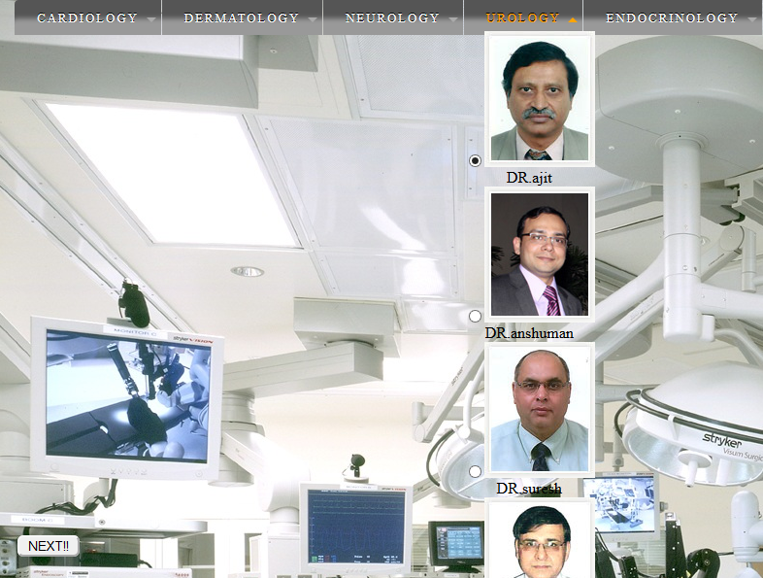 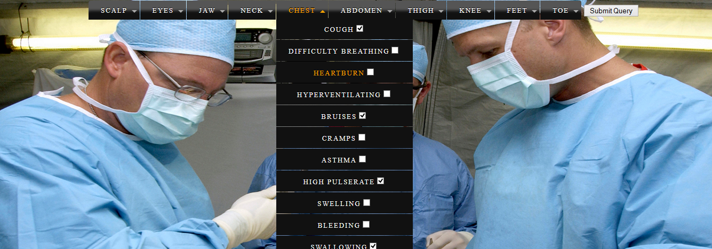

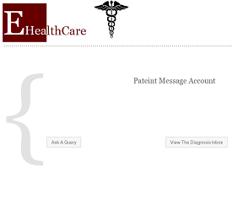 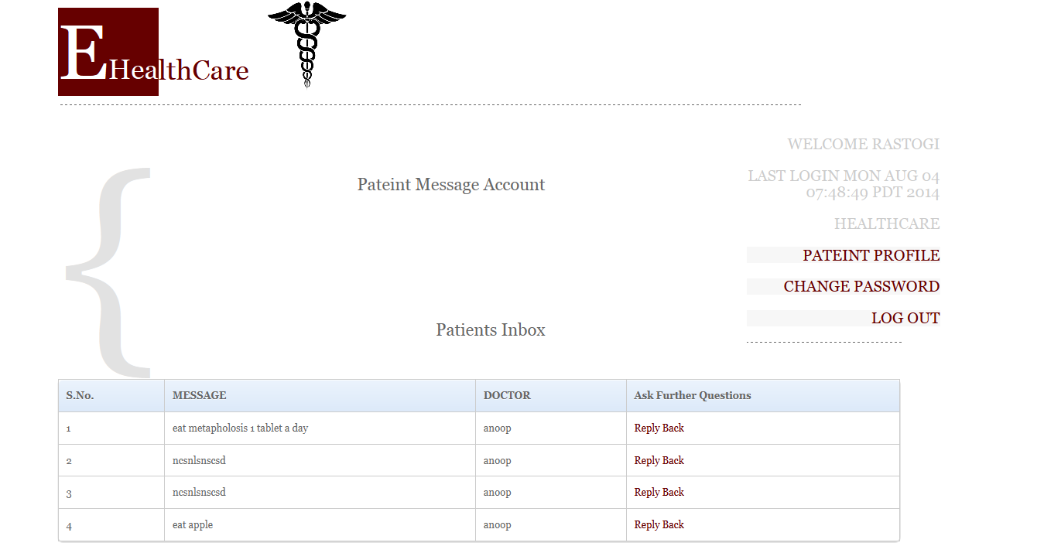

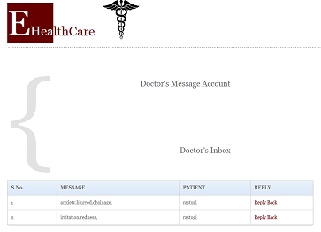

Name of the Module-6: **Feedback Module**

**Description:**

It allows all the users registered to fill the feedback response for the web application developed, radio boxes have been used to record the response and message box to store any further suggestions. The result is forwarded to the admin who can view them in feedback profile.

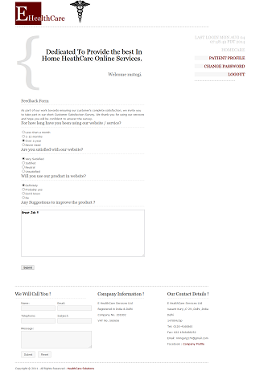 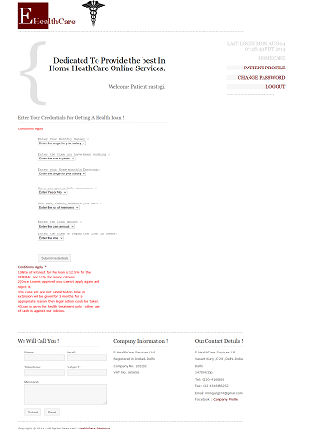

Name of the Module-4: **Loan Module**

**Description:**

It allows patients to apply for a loan. It inquires about salary of the patient and total home income, based on that it decides whether to sanction loan or not.

**DATABASE TABLES**

Patient Profile:

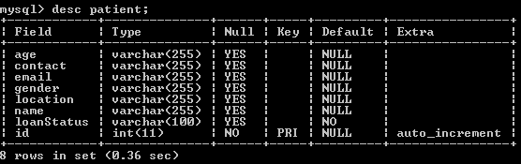

Doctor Profile:

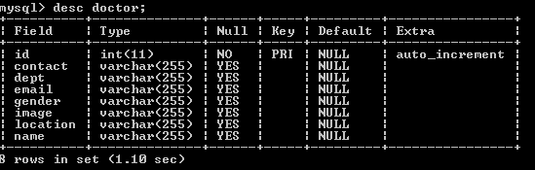

Login Table:

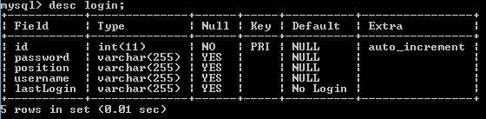

Feedback Table:

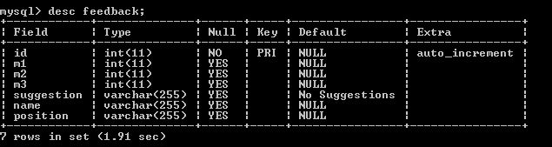

Message Table:

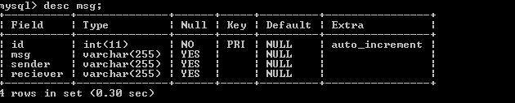

Notice Table:

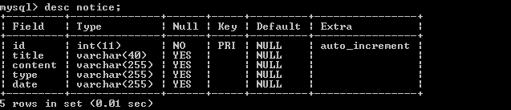

1. **Limitations**

This project is a platform for patients and doctors to interact. But this project has few limitations also:-

1. This project might slow down the server due to many images and doc files uploaded by the doctors.
2. The project is still weak from security point of view. The majors that are required to make the files and the users safe and secure are lacking.
3. Project still lacks in functionality , it should be more dynamic and functional.
4. **CONCLUSION**

The system was designed in such a way that future modifications can be done easily. The following conclusions can be deduced from the development of the project.

* + It provides a friendly graphical user interface which proves to be better when compared to the existing system.
  + It gives appropriate access to the authorized users depending on their permissions.
  + It effectively overcomes the delay in communications.
  + Updating of information becomes so easier.
  + The System has adequate scope for modification in future if it is necessary.

### The main language used in the project is JSP. It is server side language. It allows to apply object oriented concept and functions. Inserting java code in between html and css is a great feature. CSS provides a very attractive design.

**7) FUTURE ENHANCEMENTS**

1. Make a dynamic appointment module which would allow doctors to upload their schedule daily and patient can view it and book an appointment accordingly if slot available otherwise waiting list will be generated.
2. Make project globally accessible using concept of internalization.
3. Provide a list of popular doctors to patients for each department using indexing.
4. Provide an online dispensary portal to sell medicines.
5. Provide a smoother interaction and user interface using JQuery.
6. Use of AJAX to provide the information asynchronously and make an effective online chat module.
7. Implement more security measures.
8. Make an android application for the same web application.

**8)** **BIBLIOGRAPHY**

The following links were referred during the analysis and execution phase of the project:

1. <http://www.google.com>
2. [http://www.](http://www.jakarta.apache.org)youtube.com
3. <http://www.w3schools.com/>
4. <http://www.tutorialspoint.com/>
5. <http://www.stackoverflow.org/>

The following books were referred:

1. Head First Java
2. Head First JSP’s and Servlets
3. HP reference manual.